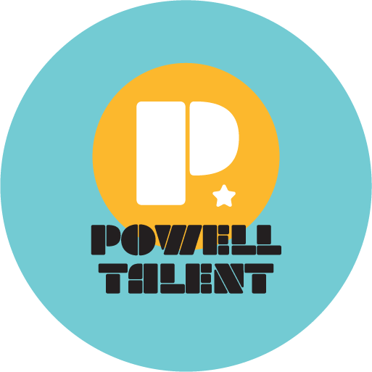

CEDRIC WILLIAMS

Cedric Williams originally from Kentucky moved to Los Angeles to pursue an on camera acting career. While auditioning for tv shows and movies, he became aware of voice acting, particularly for cartoons which he always watched. Growing up he would mimic Spongebob which was his favorite cartoon character. Something sparked and he decided to go full force in pursuing voice acting. Like his hero Spongebob he became a sponge absorbing knowledge of the craft by listening to demos, studying his favorite voice actors, and listening to podcasts.

After learning about the VO industry, he produced his own voiceover demos. He eventually got the attention of an agent and local studios. His first role was the Cartoon Network pilot “Lasso & Comet” which he got to work with veteran voice actor Richard Horvitz best known for his role of Invader Zim.

Since then he’s done work in anime, video games, original animation, and commercials. Notably Cheetu in “Hunter X Hunter'', Don in “The Promised Neverland”, Tsugawa in “Kuroko’s Basketball”, Senjuro Rengoku in Demon Slayer Mugen Train, Leon in “Pokémon Masters Ex”, Howlet Groms in “Final Fantasy War of the Visions”, Kurosawa and Junya in “Genshin Impact”, Al in “Phantasy Star Online 2”, Prince Starling in “Thundercats Roar”, Boris in the Amazon Prime animated series “Boris & Rufus”, the voice of the player in the video game “Aliens: Fireteam Elite", Drake Miller and Glowboo in Ghost Force on Disney XD, Quentin & Quincy in 9 Years to Neptune, and many more on the way.

